CO2 AT1
Name: Ayyan Abhisheshan
Reg No: 192411102
Course Code/Name: CSA1613- Data Warehousing and Data Mining
Faculty Name: Dr. Kanimozhi K.V

1. Missing Value Imputation using Mean Method (Hospital Patient Records)
Given Data

95, 102, 110, –, 120, 115, 108, –, 130, 125 Step 1: Calculate the Mean of Available Values
Available values:
95, 102, 110, 120, 115, 108, 130, 125
Sum = 95 + 102 + 110 + 120 + 115 + 108 + 130 + 125 = 905
Number of available observations = 8
Mean = 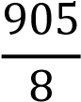 = 113.125
Mean = 113.125 mg/dL

Step 2: Replace Missing Values
Both missing values are replaced with 113.125.

Step 3: Completed Dataset
95, 102, 110, 113.125, 120, 115, 108, 113.125, 130, 125

2. Min–Max Normalization of Cholesterol Levels

Given Data
160, 180, 200, 220, 240, 260
Minimum = 160 Maximum = 260
Formula:
′ = 𝑥 − min
𝑥
max − min
𝑥 − 160 𝑥 − 160
𝑥′ = =
260 − 160 100

Cholesterol (mg/dL) | Calculation | Normalized Value
160 | (160−160)/100 | 0.00
180 | (180−160)/100 | 0.20
200 | (200−160)/100 | 0.40
220 | (220−160)/100 | 0.60
240 | (240−160)/100 | 0.80
260 | (260−160)/100 | 1.00
Final Normalized Dataset
0.00, 0.20, 0.40, 0.60, 0.80, 1.00

3. Decimal Scaling Normalization of Annual Medical Expenses
Given Data
8500, 12000, 15000, 18000, 22500, 30500, 47000

Step 1: Determine the value of j Maximum value = 47000
Decimal scaling formula: 𝑥′ = 10^{𝑥}_{𝑗}

Choose the smallest j such that
47000
^{𝑗} < 1
10

Since
47000 has 5 digits, 𝑗 = 5

Step 2: Normalize Each Observation
Original Value (₹) | Calculation | Normalized Value
8500 | 8500/100000 | 0.085
12000 | 12000/100000 | 0.120
15000 | 15000/100000 | 0.150
18000 | 18000/100000 | 0.180
22500 | 22500/100000 | 0.225
30500 | 30500/100000 | 0.305
47000 | 47000/100000 | 0.470

Final Normalized Dataset
0.085, 0.120, 0.150, 0.180, 0.225, 0.305, 0.470

Step 3: Why Decimal Scaling is Useful • Reduces the magnitude of large numbers.
- Keeps all values within a small range.
- Preserves the relative ordering of data.
- Makes data suitable for machine learning and data mining algorithms.
- Improves computational efficiency.

4. Correlation Analysis between Exercise Hours and BMI

Given Data
Exercise Hours (x) | BMI (y)
2 | 31
4 | 29
5 | 28
6 | 26
8 | 24

Step 1: Calculate Means

Mean of x
2 + 4 + 5 + 6 + 8 25
𝑥̅ = = = 5
5 5

Mean of y
31 + 29 + 28 + 26 + 24 138
𝑦̅ = = = 27.6
5 5

Step 2: Pearson Correlation Coefficient
x | y | x−x̄ | y−ȳ | (x−x̄ )(y−ȳ) | (x−x̄ )² | (y−ȳ)²
2 | 31 | -3 | 3.4 | -10.2 | 9 | 11.56
4 | 29 | -1 | 1.4 | -1.4 | 1 | 1.96
5 | 28 | 0 | 0.4 | 0 | 0 | 0.16
6 | 26 | 1 | -1.6 | -1.6 | 1 | 2.56
8 | 24 | 3 | -3.6 | -10.8 | 9 | 12.96
Totals:
∑( 𝑥 − 𝑥̅)(𝑦 − 𝑦̅) = −24
∑( 𝑥 − 𝑥̅)² = 20
∑( 𝑦 − 𝑦̅)² = 29.2

Pearson formula:
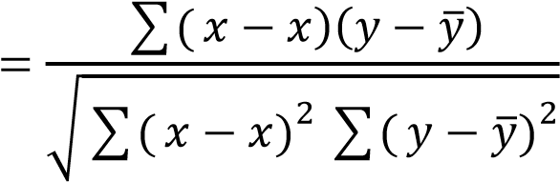
̅
𝑟
̅
𝑟 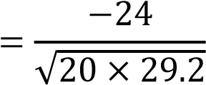
𝑟 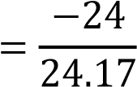
𝑟 ≈ −0.99

Step 3: Interpretation
- Pearson correlation coefficient = −0.99
- There is a very strong negative correlation between exercise hours and BMI.
- As exercise hours increase, BMI decreases.

Equal-Depth Binning using Bin Means Given Sorted Data
10, 12, 15, 18, 20, 22, 25, 28, 30, 35, 40, 45
Total observations = 12
Number of bins = 4
Each bin contains
12/4 = 3 values

Bin 1
10, 12, 15
Mean = 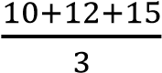 = 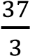 = 12.33

Smoothed Bin
12.33, 12.33, 12.33

Bin 2
18, 20, 22
Mean = 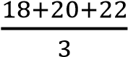 = 20

Smoothed Bin
20, 20, 20

Bin 3
25, 28, 30
Mean = 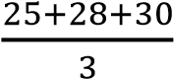 = 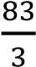 = 27.67

Smoothed Bin
27.67, 27.67, 27.67

Bin 4
35, 40, 45
Mean = 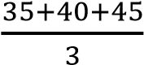 = 40

Smoothed Bin
40, 40, 40

Final Smoothed Dataset
12.33, 12.33, 12.33, 20, 20, 20, 27.67, 27.67, 27.67, 40, 40, 40

